实验报告八 查找实验
班级： 姓名： 学号： 专业：
- 实验目的：
1、熟悉线性查找算法。
2、掌握顺序查找、二分查找算法

- 实验内容：
- SeqList类中增加下列成员方法:
public int lastIndexOf(T key) //返回最后出现的关键字为key元素位置
Seqlist类：
package 数据结构JAVA.实验八.实验内容1;
import java.util.*;

import com.sun.xml.internal.ws.spi.db.DatabindingException;
class cmp<T> implements Comparator<T>{
@Override
public int compare(T o1, T o2) {
// TODO 自动生成的方法存根
Integer ele1=(Integer)o1;
Integer ele2=(Integer)o2;
return ele1.compareTo(ele2);
}
}
public class SeqList<T> {

public Vector<T> element;

public SeqList(int capicity) {
this.element=new Vector<T>(capicity);
}
public SeqList() {
this(10);
}
public void insert(T value) {
if(this.element.size()==this.element.capacity())
throw new ArrayIndexOutOfBoundsException();
this.element.add(value);
this.element.sort(new cmp<T>());
}
public int lastIndexOf(T key) {
for(int i=this.element.size()-1;i>=0;i--) {
if(this.element.get(i).equals(key))
return i;
}
throw new DatabindingException();
}
public void display() {
if(this.element.size()==0)
throw new ArrayIndexOutOfBoundsException();
for(int i=0;i<this.element.size();i++) {
System.out.print(this.element.get(i)+" ");
}
}
}

Demo类：
package 数据结构JAVA.实验八.实验内容1;
import java.util.*;
public class Demo {

public static void main(String args[]) {
int len=0;
Scanner reader=new Scanner(System.in);
len=reader.nextInt();
SeqList<Integer> a=new SeqList<Integer>(len);
for(int i=0;i<len;i++) {
int value;
value=reader.nextInt();
Integer element=new Integer(value);
a.insert(element);
}
System.out.println("Display all the element:");
a.display();
System.out.println();
System.out.print("Find element :");
int x;
x=reader.nextInt();
Integer key=new Integer(x);
int index=a.lastIndexOf(key);
System.out.println("Last index :"+" "+(index+1));
}
}
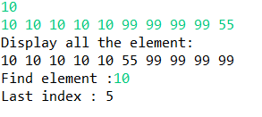

- 为顺序表和单链表增加以下基于查找的删除和替换操作的成员方法:
public void removeAll(T key) //删除所有关键字为key元素
public void replace (T x, T y) //将首次出现的元素x替换为y
public void replace(T x,T y) ) //将所有元素x替换为y
顺序表实现：

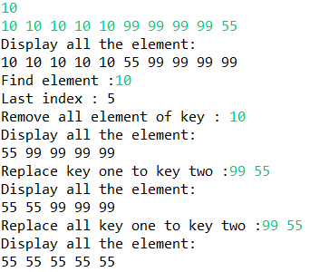
SeqListNew类：
package 数据结构JAVA.实验八.实验内容2;

public class SeqListNew<T> extends 数据结构JAVA.实验八.实验内容1.SeqList<T>{
public SeqListNew(int len) {
super(len);
}
public void removeAll(T key) {
if(this.element.isEmpty())
throw new ArrayIndexOutOfBoundsException();
for(int i=0;i<this.element.size();i++) {
if(this.element.get(i).equals(key)) {
this.element.remove(i);
i--;
}
}
}
public void replace(T x,T y) {
if(this.element.isEmpty())
throw new ArrayIndexOutOfBoundsException();
for(int i=0;i<this.element.size();i++) {
if(this.element.get(i).equals(x)) {
this.element.set(i, y);
break;
}
}
}
public void replaceAll(T x,T y) {
if(this.element.isEmpty())
throw new ArrayIndexOutOfBoundsException();
for(int i=0;i<this.element.size();i++) {
if(this.element.get(i).equals(x)) {
this.element.set(i, y);
}
}
}
}
Demo类：
package 数据结构JAVA.实验八.实验内容2;
import java.util.*;
public class Demo {

public static void main(String args[]) {
int len=0;
Scanner reader=new Scanner(System.in);
len=reader.nextInt();
SeqListNew<Integer> a=new SeqListNew<Integer>(len);
for(int i=0;i<len;i++) {
int value;
value=reader.nextInt();
Integer element=new Integer(value);
a.insert(element);
}
a.display();
System.out.print("Find element :");
int x;
x=reader.nextInt();
Integer key=new Integer(x);
int index=a.lastIndexOf(key);
System.out.println("Last index :"+" "+(index+1));
System.out.print("Remove all element of key : ");
key=reader.nextInt();
a.removeAll(key);
a.display();
System.out.print("Replace key one to key two :");
Integer key1=new Integer(0);
key=reader.nextInt();
key1=reader.nextInt();
a.replace(key, key1);
a.display();
System.out.print("Replace all key one to key two :");
key=reader.nextInt();
key1=reader.nextInt();
a.replaceAll(key, key1);
a.display();
}
}
单链表实现：
SingList类：
package 数据结构JAVA.实验八.实验内容2;
class node<T> {
public T data;
public node<T> next;
public node() {
this.data=null;
this.next=null;
}
public node(T data) {
this.data=data;
this.next=null;
}
}
public class SingleList<T> {

public node<T> head;
public SingleList() {
this.head=new node<T>();
}
public node<T> findLastElement() {
node<T> p=this.head;
while(p.next!=null)
p=p.next;
return p;
}
public void insert(T data) {
node<T> element=new node<T>(data);
node<T> p=this.findLastElement();
p.next=element;
}
public void display() {
System.out.println("Display all the element:");
node<T> p=this.head;
while(p.next!=null) {
System.out.print(p.next.data+" ");
p=p.next;
}
System.out.println();
}
public void removeAll(T key) {
node<T> p=this.head;
while(p.next!=null) {
if(p.next.data.equals(key)) {
p.next=p.next.next;
continue;
}
p=p.next;
}
}
public void replaceAll(T x,T y) {
node<T> p=this.head;
while(p.next!=null) {
if(p.next.data.equals(x))
p.next.data=y;
p=p.next;
}
}
public void replace(T x,T y) {
node<T> p=this.head;
while(p.next!=null) {
if(p.next.data.equals(x)) {
p.next.data=y;
break;
}
p=p.next;
}
}
}
Demo类：
package 数据结构JAVA.实验八.实验内容2;
import java.util.*;
public class Demo {

public static void main(String args[]) {
int len=0;
Scanner reader=new Scanner(System.in);
len=reader.nextInt();
SingleList<Integer> a=new SingleList<Integer>();
for(int i=0;i<len;i++) {
int value;
value=reader.nextInt();
Integer element=new Integer(value);
a.insert(element);
}
a.display();
//System.out.print("Find element :");
int x=0;
//x=reader.nextInt();
Integer key=new Integer(x);
//int index=a.lastIndexOf(key);
//System.out.println("Last index :"+" "+(index+1));
System.out.print("Remove all element of key : ");
key=reader.nextInt();
a.removeAll(key);
a.display();
System.out.print("Replace key one to key two :");
Integer key1=new Integer(0);
key=reader.nextInt();
key1=reader.nextInt();
a.replace(key, key1);
a.display();
System.out.print("Replace all key one to key two :");
key=reader.nextInt();
key1=reader.nextInt();
a.replaceAll(key, key1);
a.display();
}
}

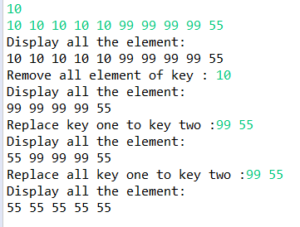
3、有序表的二分查找（折半查找）
SeqListNew2类：
package 数据结构JAVA.实验八.实验内容3;

import 数据结构JAVA.实验八.实验内容2.SeqListNew;
import 数据结构JAVA.实验八.实验内容1.Comp;
import 数据结构JAVA.实验八.实验内容1.SeqList;
public class SeqListNew2<T> extends SeqListNew<T>{

public SeqListNew2(int len) {
super(len);
}
public int BinaryfindKey(T key) {
int left=0,right=this.element.size()-1;
Comp<T> cmp=new Comp<T>();
while(left<=right) {
int mid=(left+right)/2;
int com=cmp.compare(this.element.get(mid), key);
if(com==1) {
right=mid-1;
}else if(com==0) {
return mid;
}else {
left=mid+1;
}
}
throw new ArrayIndexOutOfBoundsException();
}
}
Demo类：
package 数据结构JAVA.实验八.实验内容3;

import java.util.Scanner;

import 数据结构JAVA.实验八.实验内容1.Comp;

public class Demo {

public static void main(String args[]) {
Scanner reader=new Scanner(System.in);
int len=reader.nextInt();
SeqListNew2<Integer> vector=new SeqListNew2<Integer>(len);
for(int i=0;i<len;i++) {
int value=reader.nextInt();
vector.insert(value);
}
System.out.print("Input data you want to ensure :");
int data=reader.nextInt();
int index=vector.BinaryfindKey(data);
vector.display();
System.out.print("Data you want is locate in this index :");
System.out.println((index+1));
System.out.println("Data :"+vector.element.get(index));
}
}
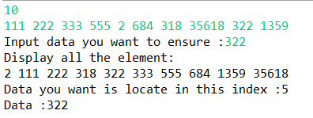

- 实验心得（含上机中所遇问题的解决办法，所使用到的编程技巧、创新点及编程的心得）
- 利用继承类，减少编程量。
- 使用vector代替int或者泛型数组，可以依需求开辟数组空间。

